In order to improve the accuracy of the meter, you need to manually calibrate the unit.
Calibration is done by changing the values of the constants used in the code. The calibration data consists of 168 points. These points are the ESR values at every 0x10 ADC counts.
Note that CALIB1[0] is always zero and CALIB2[0] = CALIB1[84].
Code:
#
-- calibration data
-- this is split in two tables since it cannot fit on a single bank of the PIC
const word CALIB1[] = {
0x0000, 0x0036, 0x0041, 0x004B, 0x0056, 0x0060, 0x006B,
0x0075, 0x0080, 0x008A, 0x0094, 0x009F, 0x00A9, 0x00B3,
0x00BD, 0x00C8, 0x00D2, 0x00DC, 0x00E6, 0x00F0, 0x00FB,
0x0105, 0x010F, 0x0119, 0x0124, 0x012E, 0x0139, 0x0143,
0x014D, 0x0158, 0x0163, 0x016D, 0x0178, 0x0183, 0x018E,
0x0199, 0x01A4, 0x01AF, 0x01BA, 0x01C6, 0x01D1, 0x01DD,
0x01E8, 0x01F4, 0x0200, 0x020C, 0x0218, 0x0225, 0x0231,
0x023E, 0x024A, 0x0257, 0x0265, 0x0272, 0x027F, 0x028D,
0x029B, 0x02A9, 0x02B7, 0x02C5, 0x02D4, 0x02E2, 0x02F1,
0x0300, 0x0310, 0x031F, 0x032F, 0x033F, 0x0350, 0x0360,
0x0371, 0x0382, 0x0393, 0x03A5, 0x03B7, 0x03C9, 0x03DB,
0x03EE, 0x0400, 0x0414, 0x0427, 0x043B, 0x044F, 0x0463,
0x0478 }
-- the first element of the next table is the value of the last element in the
-- previous table, i.e. CALIB2[0] == CALIB1[MAX_INDEX]
const word CALIB2[] = {
0x0478, 0x048D, 0x04A2, 0x04B8, 0x04CE, 0x04E5, 0x04FC,
0x0513, 0x052B, 0x0543, 0x055D, 0x0576, 0x0591, 0x05AC,
0x05C7, 0x05E4, 0x0601, 0x061F, 0x063E, 0x065D, 0x067E,
0x069F, 0x06C2, 0x06E5, 0x070A, 0x072F, 0x0756, 0x077D,
0x07A6, 0x07D0, 0x07FB, 0x0828, 0x0855, 0x0884, 0x08B5,
0x08E6, 0x0919, 0x094E, 0x0984, 0x09BB, 0x09F4, 0x0A2E,
0x0A6A, 0x0AA8, 0x0AE8, 0x0B2A, 0x0B6F, 0x0BB7, 0x0C02,
0x0C50, 0x0CA3, 0x0CF9, 0x0D55, 0x0DB5, 0x0E1A, 0x0E85,
0x0EF5, 0x0F6C, 0x0FE8, 0x106C, 0x10F7, 0x118A, 0x1227,
0x12CE, 0x1380, 0x143E, 0x150A, 0x15E3, 0x16CA, 0x17C2,
0x18CA, 0x19E4, 0x1B11, 0x1C51, 0x1DAD, 0x1F30, 0x20E6,
0x22DA, 0x2518, 0x27AC, 0x2AA2, 0x2E04, 0x31E0, 0x363F,
0x3B2F }
REQUIREMENTS
- Multimeter
- 200 ohms trimmer resistor
The trimmer resistor is soldered to a 3 pin header to facilitate in shorting out the inputs:
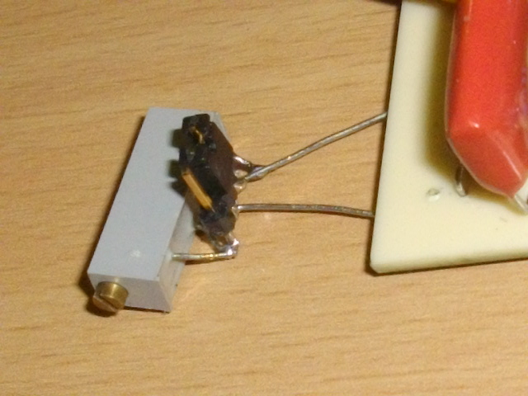
TEST SETUP
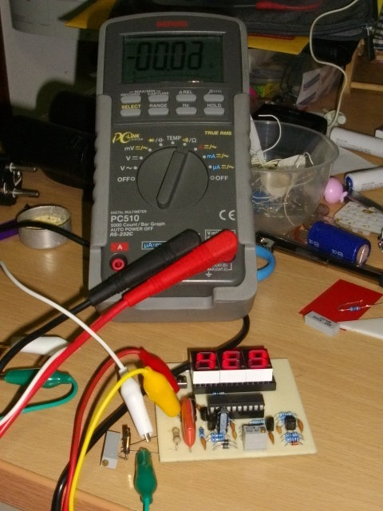
The multimeter is directly connected to the trimmer resistor.
Note that there is a 1M ohm resistor in parallel with the inputs, since this is very high it can be safely ignored.
PROCEDURE
All the measurements are done in calibration mode, with the readings zeroed out when the inputs are shorted.
Adjust the 200 ohm trimmer until the display shows 010, record the resistance on the second entry of CALIB1 table.
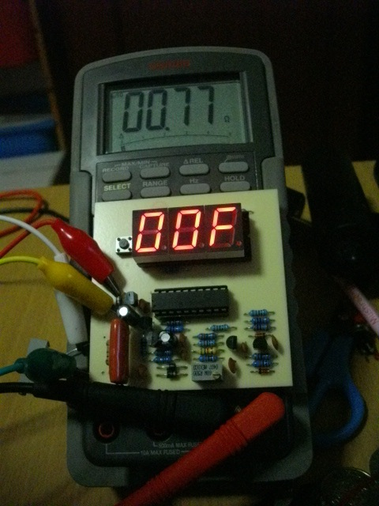
Adjust the trimmer again to display 020, record the resistance value... Repeat these steps until you reach the A80 reading.
Update the source code , recompile and upload the firmware. You now have a fully calibrated meter capable of measuring 0.01 ohm to 150 ohm ESR with good accuracy.

